AN LAC SEAFOOD CO., LTD. (HK216)
No. 38, 2A Street, Hung Vuong South – Tran Van Kieu North Residential Area, An Lac Ward, Binh Tan District, Hochiminh City, Vietnam.

No.: 07/ALC/ 2011
STATEMENT

TO.: SHING YUEH INTERNATIONAL CO., LTD.

DATE | INVOICE NO. | AWB | TOTAL
02 MAR. | 019/ALC | 695 3394 8202 | 6,493.62
03 MAR. | 020/ALC | 695 3394 9344 | 7,186.38
04 MAR. | 021/ALC | 695 3339 3861 | 8,959.95
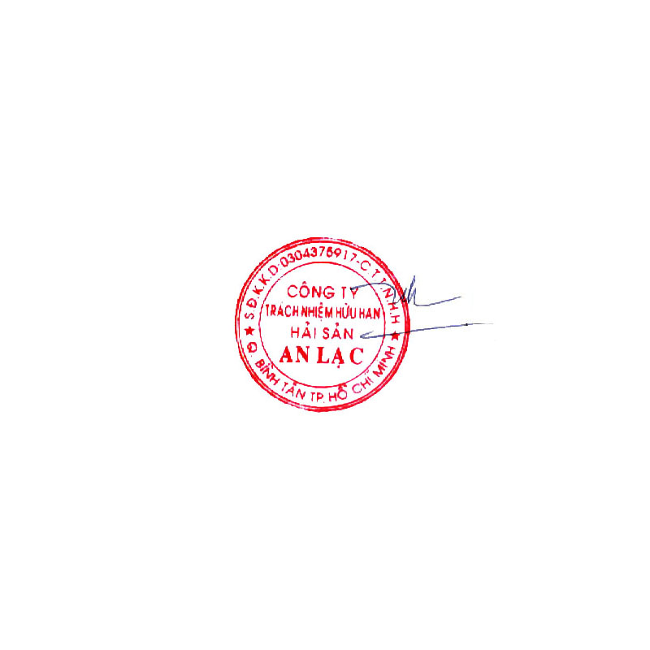  GRAND TOTAL |  |  | USD 22,639.95

Says: US DOLLARS Twenty Two Thousand Six Hundred Thirty Nine And Ninety-Five Cents Only.
AN LAC SEAFOOD CO., LTD.
Account No. : 1402 1485 100 3419
Name Of Bank : EXIMBANK, DISTRICT 4 BRANCH, HOCHIMINH CITY, VIETNAM.
SWIFT : EBVIVNVXQ04
AN LAC SEAFOOD CO., LTD.

Lê Thị Hoa

